Angebot freibleibend - Zwischenverkauf vorbehalten

free offer - subject to being unsold

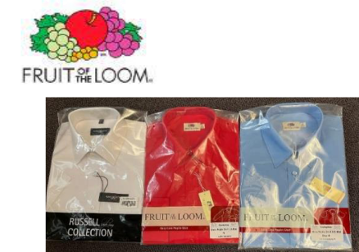

Shirts for Women + Men
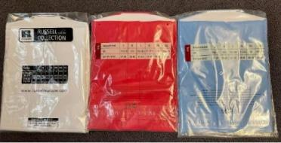

 |  |  |  |  |  |  | XS | S | M | L | XL | 2XL | 3XL | 4XL | TOTAL
 |  |  |  |  | Ladies Shirts short sleeves |  | 1.388 | 1.434 | 1.209 | 893 | 675 | 686 | 741 | 512 | 7.538
 |  |  |  |  | Mens Shirts short sleeves |  |  | 2.062 | 1.848 | 1.558 | 994 | 493 | 486 | 272 | 7.713
 |  |  |  |  | Mens Shirts long sleeves |  |  | 2.637 | 1.315 | 900 | 736 | 656 | 894 | 87 | 7.225
 |  | (pls refer to below details / Artikeldetails s.unten ) |  |  | Grand total All Shirts |  |  |  |  |  |  |  |  |  | 22.476
Category | Gender | Picture | Style | Style Description | Colour | Colour Desc | XS | S | M | L | XL | 2XL | 3XL | 4XL | TOTAL
SHIRT | LADIES |  | 0650000 | Ladies Short Sleeve Oxford Shirt | 36 | Black | 79 | 26 | 175 | 87 | 16 | 42 | 21 |  | 446
SHIRT | LADIES |  | 0650000 | Ladies Short Sleeve Oxford Shirt | 32 | Navy | 168 | 23 | 16 | 9 | 21 | 57 | 70 |  | 364
SHIRT | LADIES |  | 0650000 | Ladies Short Sleeve Oxford Shirt | OD | Oxford Blue | 7 | 83 | 317 | 59 | 85 | 67 | 15 |  | 633
SHIRT | LADIES |  | 0650000 | Ladies Short Sleeve Oxford Shirt | OC | Oxford Grey | 7 | 10 | 8 | 36 | 12 |  | 12 |  | 85
SHIRT | LADIES |  | 0650000 | Ladies Short Sleeve Oxford Shirt | 30 | White | 97 | 42 | 29 | 24 | 12 | 12 | 14 |  | 230
Total |  |  |  |  |  |  | 358 | 184 | 545 | 215 | 146 | 178 | 132 |  | 1.758
SHIRT | LADIES |  | 0650140 | Ladies Short Sleeve Poplin Shirt | 36 | Black | 32 | 36 | 17 | 18 | 27 | 13 | 12 |  | 155
SHIRT | LADIES |  | 0650140 | Ladies Short Sleeve Poplin Shirt | MU | Mid Blue | 24 | 79 | 88 | 104 | 36 | 11 | 2 |  | 344
SHIRT | LADIES |  | 0650140 | Ladies Short Sleeve Poplin Shirt | 32 | Navy | 81 | 228 | 61 | 149 | 68 | 80 | 73 |  | 740
SHIRT | LADIES |  | 0650140 | Ladies Short Sleeve Poplin Shirt | 40 | Red | 45 | 144 | 31 | 58 | 12 | 41 | 10 |  | 341
SHIRT | LADIES |  | 0650140 | Ladies Short Sleeve Poplin Shirt | 30 | White | 103 | 1 |  | 60 | 48 | 20 | 46 |  | 278
Total |  |  |  |  |  |  | 285 | 488 | 197 | 389 | 191 | 165 | 143 |  | 1.858
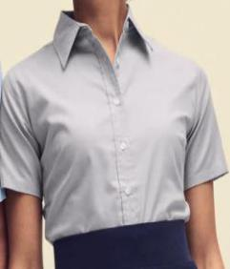
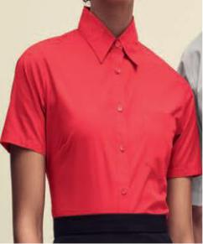

ca. Mengen

approx. quantities

Seite 1 von 4 Shirts DOB+Haka
Angebot freibleibend - Zwischenverkauf vorbehalten

free offer - subject to being unsold

 | Category | Gender |  | Picture | Style | Style Description | Colour | Colour Desc | XS | S | M | L | XL | 2XL | 3XL | 4XL | TOTAL
 | SHIRT | LADIES |  |  | 0R961F0 | Ladies' SS Fit Ult Stretch Shirt | 36 | Black | 91 | 93 |  | 12 |  | 39 | 100 | 14 | 349
 | SHIRT | LADIES |  |  | 0R961F0 | Ladies' SS Fit Ult Stretch Shirt | NB | Bright Navy | 69 | 10 | 14 |  | 20 | 53 | 18 | 84 | 268
 | SHIRT | LADIES |  |  | 0R961F0 | Ladies' SS Fit Ult Stretch Shirt | BZ | Bright Sky | 112 | 187 | 148 | 88 | 54 | 82 | 59 | 90 | 820
 | Total |  |  |  |  |  |  |  | 272 | 290 | 162 | 100 | 74 | 174 | 177 | 188 | 1.437
 | SHIRT | LADIES |  |  | 0R925F0 | Lds CapS Fit Poly-Ct Ppln Shirt | 36 | Black | 7 |  | 4 | 8 | 10 | 8 | 2 |  | 39
 | SHIRT | LADIES |  |  | 0R925F0 | Lds CapS Fit Poly-Ct Ppln Shirt | CR | Classic Red | 117 | 224 | 199 | 84 | 86 | 36 | 140 | 50 | 936
 | SHIRT | LADIES |  |  | 0R925F0 | Lds CapS Fit Poly-Ct Ppln Shirt | CG | Convoy Grey | 84 | 12 | 1 |  | 1 | 25 | 65 | 82 | 270
 | SHIRT | LADIES |  |  | 0R925F0 | Lds CapS Fit Poly-Ct Ppln Shirt | CP | Corporate Blue | 111 | 156 | 22 | 7 | 3 | 58 | 11 | 115 | 483
 | SHIRT | LADIES |  |  | 0R925F0 | Lds CapS Fit Poly-Ct Ppln Shirt | FN | French Navy | 69 |  | 12 | 12 | 2 | 12 | 60 | 40 | 207
 | SHIRT | LADIES |  |  | 0R925F0 | Lds CapS Fit Poly-Ct Ppln Shirt | 30 | White | 3 | 8 | 5 | 4 | 3 | 2 | 4 | 15 | 44
 | SHIRT | LADIES |  |  | 0R937F0 | Lds SS Clas Pure-Ct Ppln Shirt | 36 | Black | 8 | 9 | 18 |  | 12 |  | 2 | 14 | 63
 | SHIRT | LADIES |  |  | 0R937F0 | Lds SS Clas Pure-Ct Ppln Shirt | 30 | White | 74 | 3 | 44 | 14 | 87 | 4 | 5 | 8 | 239
 | SHIRT | LADIES |  |  | 0R919F0 | Lds Roll SS Fit Twill Shirt | 30 | White |  | 24 |  | 60 | 60 | 24 |  |  | 168
 | SHIRT | LADIES |  |  | 0R990F0 | Sleeveless Stretch Top Black S | 36 | Black |  | 36 |  |  |  |  |  |  | 36
 | Total |  |  |  |  |  |  |  | 473 | 472 | 305 | 189 | 264 | 169 | 289 | 324 | 2.485
 | Grand total Ladies Shirts |  |  |  |  |  |  |  | 1.388 | 1.434 | 1.209 | 893 | 675 | 686 | 741 | 512 | 7.538
 | Category | Gender |  | Picture | Style | Style Description | Colour | Colour Desc |  | S | M | L | XL | 2XL | 3XL | 4XL | TOTAL
 | SHIRT | MEN |  |  | 0651120 | Short Sleeve Oxford Shirt | 36 | Black |  | 135 | 52 | 71 | 75 | 17 | 5 |  | 355
 | SHIRT | MEN |  |  | 0651120 | Short Sleeve Oxford Shirt | 32 | Navy |  | 39 | 8 | 10 | 7 |  |  |  | 64
 | SHIRT | MEN |  |  | 0651120 | Short Sleeve Oxford Shirt | OD | Oxford Blue |  | 53 | 552 | 232 | 14 | 23 | 10 |  | 884
 | SHIRT | MEN |  |  | 0651120 | Short Sleeve Oxford Shirt | OC | Oxford Grey |  | 188 | 94 | 98 |  |  | 12 |  | 392
 | SHIRT | MEN |  |  | 0651120 | Short Sleeve Oxford Shirt | 30 | White |  | 29 | 239 | 134 | 12 |  |  |  | 414
 | Total |  |  |  |  |  |  |  |  | 444 | 945 | 545 | 108 | 40 | 27 |  | 2.109
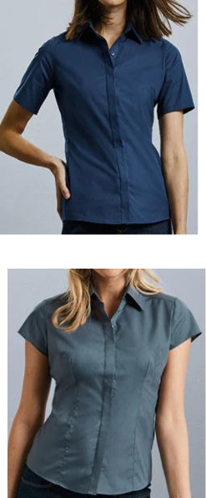
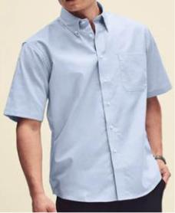

ca. Mengen

approx. quantities

Seite 2 von 4 Shirts DOB+Haka
Angebot freibleibend - Zwischenverkauf vorbehalten

free offer - subject to being unsold

 | Category | Gender | Picture | Style | Style Description | Colour | Colour Desc | XS | S | M | L | XL | 2XL | 3XL | 4XL | TOTAL
 | SHIRT | MEN |  | 0651160 | Short Sleeve Poplin Shirt | 36 | Black |  | 430 | 40 | 202 | 185 | 67 | 17 |  | 941
 | SHIRT | MEN |  | 0651160 | Short Sleeve Poplin Shirt | MU | Mid Blue |  | 125 | 85 | 146 | 104 | 32 | 17 |  | 509
 | SHIRT | MEN |  | 0651160 | Short Sleeve Poplin Shirt | 32 | Navy |  | 47 | 71 | 62 | 363 | 111 | 144 |  | 798
 | SHIRT | MEN |  | 0651160 | Short Sleeve Poplin Shirt | 40 | Red |  | 167 | 47 | 25 | 12 | 19 | 23 |  | 293
 | SHIRT | MEN |  | 0651160 | Short Sleeve Poplin Shirt | 30 | White |  | 379 | 71 | 24 |  | 27 |  |  | 501
 | Total |  |  |  |  |  |  |  | 1.148 | 314 | 459 | 664 | 256 | 201 |  | 3.042
 | SHIRT | MEN |  | 0R961M0 | Men's SS Fit Ult Stretch Shirt | NB | Bright Navy |  | 16 |  |  |  | 20 | 51 | 65 | 152
 | SHIRT | MEN |  | 0R961M0 | Men's SS Fit Ult Stretch Shirt | BZ | Bright Sky |  | 188 | 306 | 202 | 159 | 153 | 86 | 118 | 1.212
 | Total |  |  |  |  |  |  |  | 204 | 306 | 202 | 159 | 173 | 137 | 183 | 1.364
 | SHIRT | MEN |  | 0R925M0 | Men's SS Tail Po-Ct Ppln Shirt | CR | Classic Red |  | 154 | 76 | 82 | 2 | 1 | 57 | 59 | 431
 | SHIRT | MEN |  | 0R925M0 | Men's SS Tail Po-Ct Ppln Shirt | CG | Convoy Grey |  | 12 | 8 |  | 2 | 9 | 11 | 4 | 46
 | SHIRT | MEN |  | 0R925M0 | Men's SS Tail Po-Ct Ppln Shirt | CP | Corporate Blue |  | 3 | 7 | 11 |  | 10 | 1 | 6 | 38
 | SHIRT | MEN |  | 0R925M0 | Men's SS Tail Po-Ct Ppln Shirt | FN | French Navy |  | 86 | 12 |  | 8 | 2 | 1 | 5 | 114
 | SHIRT | MEN |  | 0R919M0 | Men's Roll SS Fit Twl Shirt | XW | Zinc |  |  |  |  | 12 |  |  |  | 12
 | SHIRT | MEN |  | 0R937M0 | Men's SS Clas Pure-Ct Ppln Shirt | 30 | White |  | 11 | 180 | 259 | 39 | 2 | 51 | 15 | 557
 | Total |  |  |  |  |  |  |  | 266 | 283 | 352 | 63 | 24 | 121 | 89 | 1.198
 | Grand total short sleeve shirts MEN |  |  |  |  |  |  |  | 2.062 | 1.848 | 1.558 | 994 | 493 | 486 | 272 | 7.713
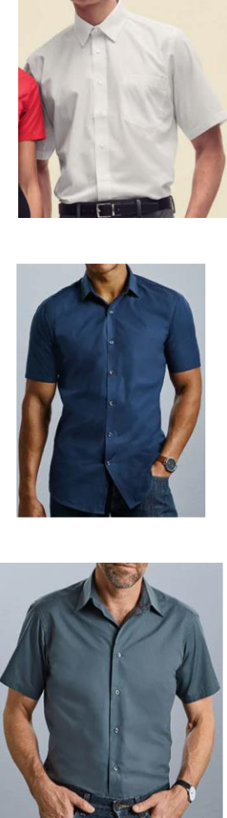

ca. Mengen

approx. quantities

Seite 3 von 4 Shirts DOB+Haka
Angebot freibleibend - Zwischenverkauf vorbehalten

free offer - subject to being unsold

 | Category | Gender |  | Picture | Style | Style Description | Colour | Colour Desc | XS | S | M | L | XL | 2XL | 3XL | 4XL | TOTAL
 | SHIRT | MEN |  |  | 0651180 | Long Sleeve Poplin Shirt | 32 | Navy |  | 312 | 35 | 63 | 190 | 147 | 221 |  | 968
 | SHIRT | MEN |  |  | 0651180 | Long Sleeve Poplin Shirt | 40 | Red |  | 265 | 216 | 374 | 266 | 393 | 247 |  | 1.761
 | Total |  |  |  |  |  |  |  |  | 577 | 251 | 437 | 456 | 540 | 468 |  | 2.729
 | SHIRT | MEN |  |  | 0651140 | Long Sleeve Oxford Shirt | 32 | Navy |  | 402 | 33 | 7 | 12 |  | 80 |  | 534
 | SHIRT | MEN |  |  | 0651140 | Long Sleeve Oxford Shirt | OD | Oxford Blue |  | 642 | 639 | 126 | 50 | 11 | 5 |  | 1.473
 | SHIRT | MEN |  |  | 0651140 | Long Sleeve Oxford Shirt | 30 | White |  | 559 | 131 | 154 | 145 | 86 | 169 |  | 1.244
 | Total |  |  |  |  |  |  |  |  | 1.603 | 803 | 287 | 207 | 97 | 254 |  | 3.251
 | SHIRT | MEN |  |  | 0R928M0 | Men's LS Tail Bt-D Oxford Shirt | 36 | Black |  | 305 | 237 | 176 | 72 | 4 | 142 | 37 | 973
 | SHIRT | MEN |  |  | 0R966M0 | LSTailored Ultimate Stretch-Shirt | B2 | Black/Oxford Grey/Convoy Gre |  | 119 | 24 |  | 1 | 9 | 11 | 15 | 179
 | SHIRT | MEN |  |  | 0R966M0 | LSTailored Ultimate Stretch-Shirt | B4 | Bright Navy/Oxford Blue/Whit |  | 6 |  |  |  |  | 8 | 19 | 33
 | SHIRT | MEN |  |  | 0R966M0 | LSTailored Ultimate Stretch-Shirt | W8 | White/Oxford Blue/Bright Nav |  | 27 |  |  |  | 6 | 11 | 16 | 60
 | Total |  |  |  |  |  |  |  |  | 457 | 261 | 176 | 73 | 19 | 172 | 87 | 1.245
 | Total long sleeve shirts MEN |  |  |  |  |  |  |  |  | 2.637 | 1.315 | 900 | 736 | 656 | 894 | 87 | 7.225
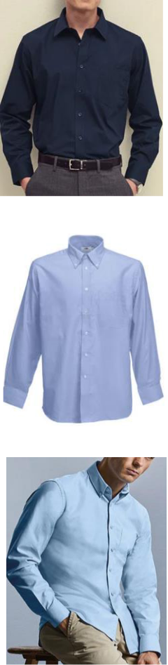

ca. Mengen

approx. quantities

Seite 4 von 4 Shirts DOB+Haka

